|  |  |  |
| --- | --- | --- |
| **Course : (WEB322) -Web Programming Tools and Frameworks** | **Assignment 1 of 5** | **Contribution:10% of course** |
| **Instructor : Kadeem Best** | **Date Given: January 27th 2020** | **Date Due:February 10th 2020** |

**Notes for the Student:** This Assignment is one of five that is designed to give you practical experience in building Dynamic websites and Server-Side Web applications using Node.js and Express.

**Background**: You will need to have access to a code editor. You will also need a thorough understanding of HTML 5, CSS3, Javascript, “Node.JS”, Express and Handlebars.

**Assignment Submission Requirements**

* An electronic copy of your work (both the web application and a written report) should be uploaded to the Blackboard by midnight on the deadline date.
* **This Assignment WILL NOT BE ACCEPTED VIA EMAIL.**
* The written report must be in pdf format and must contain the following :-
  + A cover page.
  + A table of contents.
  + Screenshots of your website, with relevant descriptions, detailing whether the functionality was met or not met, as specified below.

## **Assignment Regulations**

* **This assignment must be done individually.**
* **Please review Seneca’s policies on Academic Integrity, specifically:**

*“Each student should be aware of the College's policy regarding Cheating and Plagiarism. Seneca's Academic Policy will be strictly enforced.To support academic honesty at Seneca College, all work submitted by students may be reviewed for authenticity and originality, utilizing software tools and third party services. Please visit the Academic Honesty site on http://library.senecacollege.ca for further information regarding cheating and plagiarism policies and procedures.  
.”* ***Thus, ensure that your code or any part of it is not duplicated by another student(s). This will result in a percentage of zero (0%) assigned to all parties involved.***

**Technical Requirements**

* All back-end functionality **MUST** be done using **Node JS and Express**.
* Your views **MUST** be created with **Express-Handlebars**
* **Your are not allowed to use any Front-End CSS or JavaScript Frameworks.**

# **Detailed App Specification**

Amazon is an ecommerce website that allows people to buy products from anywhere in the world. You have been contracted as a Full Stack developer to develop your version of the Amazon website.

The implementation of the entire functionality for the website will be spanned over 5 Assignments.

In this assignment, you will **ONLY** focus on building views for your website/web application. **No database connectivity is required for Assignment 1.**

|  |
| --- |
| REMINDER:  All back-end functionality **MUST** be done using **Node JS and Express**.  Your views **MUST** be created with **Express-Handlebars** |

Specifically, you are **ONLY** required to implement the following :

# Features

# 

# Express web server set up

Create an Express web server that listens to incoming HTTP requests.

# Route Handlers Implementation

Ensure that you create route handlers that will direct users to specific views when they navigate to the following routes:

* Home
* Products Page
* Customer Registration
* Login

# 

## Home Page

You are required to build a **well designed** home page that consists of the following sections:

* **Header -** The header **MUST** contain the logo of your Amazon website and could contain the navigation bar and any other other content you deem necessary.
* **A Navigation bar** - The navigation bar can be within the header or defined as an entirely new area. It **MUST** have links that navigates visitors to a sign up page and the login page. Please note, **instead of creating a separate page for the sign up page and the login page, you can render it as modal pop-up boxes**.
* **Promotional Section** - This section should present a banner image depicting a given promotion that is currently running .
* **Product Category Section** - This section must display at least four (4) product categories of your choice, as shown in figure 1.1. Please note, for this Assignment, Assignment 1, the data for this section must be static, i.e, it will not be pulling from a database. However, you are required to define the data in a separate module (Javascript file).

**Figure 1.1**

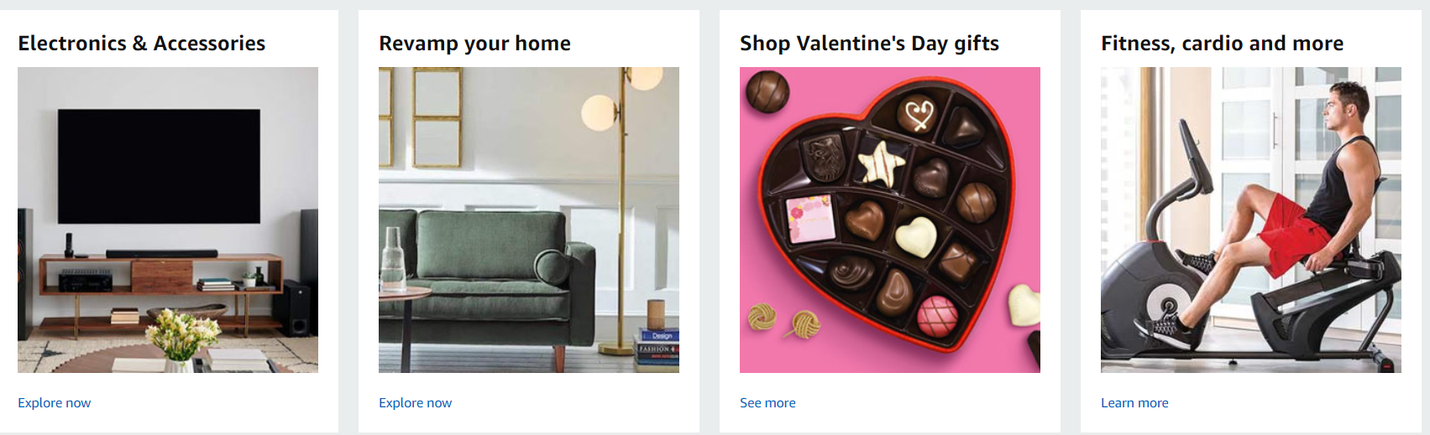

* **Best Seller Section**- This section must display a list of “**best seller**” products. See Figure 1.2 . Please note, for this Assignment, Assignment 1, the data for this section must be static. However, you are required to define the data in a separate module (Javascript file).

**Figure 1.2**

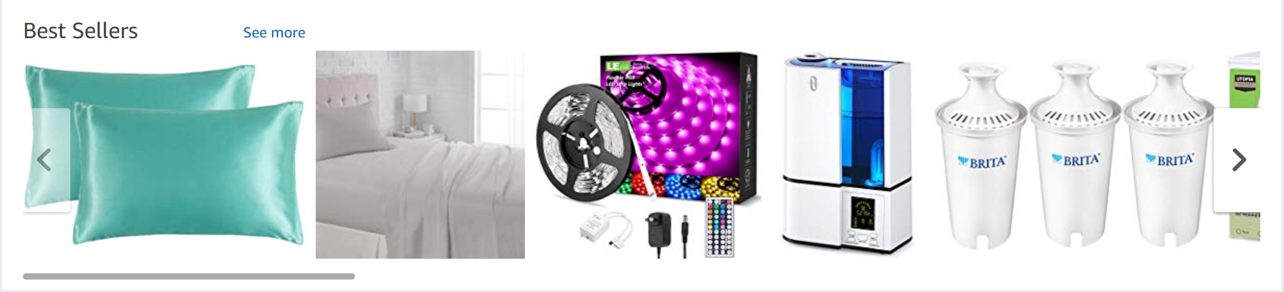

* Footer - This section **must** include footer menu items, social media links, and any other information you deem necessary.

## Products Listing page

You are required to build a **well designed** product listing page that lists at least **6 sample products in a grid with 3 columns,** as shown in the below Figure 1.2 :

**Figure 1.3**

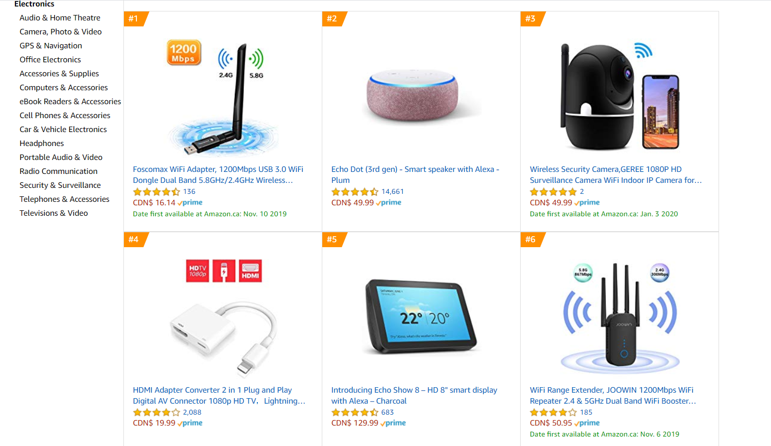

**Note, every product must have an image, title, price, category and a boolean attribute indicating if it is a best seller or not.** This view, must also have a header, navigation and footer like the home page.

Like the Product Category Section and the Best Seller section, for this Assignment, Assignment 1, the data for this section must be static, i.e, it will not be pulling from a database. However, you are required to define the data in a separate module (Javascript file).

**Please be advised that you have the option of creating one separate module file to encapsulate all the static data “fake database data” for the Product Categories section, the Best Seller Section and for the Product Listing Page. This module/JavaScript file is going to represent the Model for your MVC application.**

## Registration Page

You are required to build a **well designed** user registration form as shown in **Figure1.4** . This can be implemented as an entirely new page or as a pop-up modal. In the event you implement this as a new page then you must ensure that the page maintains consistency regarding its structure, header, nav, footer,etc as the home page.

**Figure 1.4**

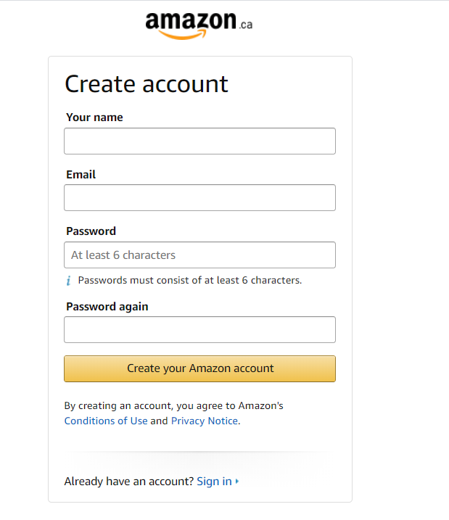

## Login Page

You are required to build a **well designed** login form as shown in **Figure1.5** . This can be implemented as an entirely new page or as a pop-up modal. In the event you implement this as a new page then you must ensure that the page maintains consistency regarding its structure, header, nav, footer,etc as the home page.

**Figure1.5**

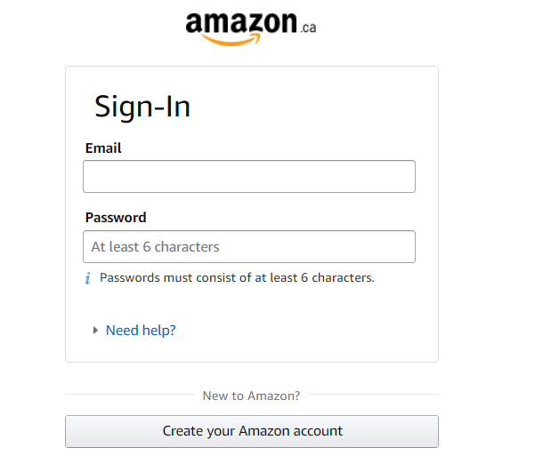

REMINDER:All back-end functionality **MUST** be done using **Node JS and Express**.

Your views **MUST** be created with **Express-Handlebars. You must create Model(s)** to encapsulate the static data (“fake database data”) for the **Product Categories section, the Best Seller Section and for the Product Listing Page.**

## 

## 

## 

## 

## Rubric

|  |  |  |  |
| --- | --- | --- | --- |
| **Criteria** | **Not Implemented**  **0** | **Partially**  **Implemented**  **1** | **Fully**  **Implemented**  **2** |
| Home View   * Header * Navigation * Promotional Section * Product Category Section * Best Seller Section * Footer |  |  |  |
| Product Listing Page   * Products listing in a grid * Each product displays the required data on the page as per the requirements. |  |  |  |
| Registration /Login View or Popup   * Registration form * Login form |  |  |  |
| Models   * The static data for the Product category section is encapsulated into a separate module (Javascript file) * The static data for the Best Seller category section is encapsulated into a separate module (Javascript file) * The static data for the Product Listing page is encapsulated into a separate module (Javascript file) |  |  |  |
| Overall look and feel   * Overall site is polished * Used pleasing typography, color palettes, and imagery * Color and layout are cohesive throughout the site * Appropriate use of grids | **Poor** | **Average** | **Exceeds** |

**Total : 34 MARKS**

**THE END**